**WordWizard Game Layout, Design and Function**

**Submitted by**

Team West

**Submitted on**

July 7, 2020

**Team Members**

Jeremy Gallagher

Hailey Gibson

Jon-Erik Prichard

1. **WordWizard Design and Function: Game Entry Screen**

1. **WordWizard Design and Function: Game Main Menu**

1. **WordWizard Design and Function: Play Game Affirmation**

1. **WordWizard Design and Function: Game Top Results Screen**

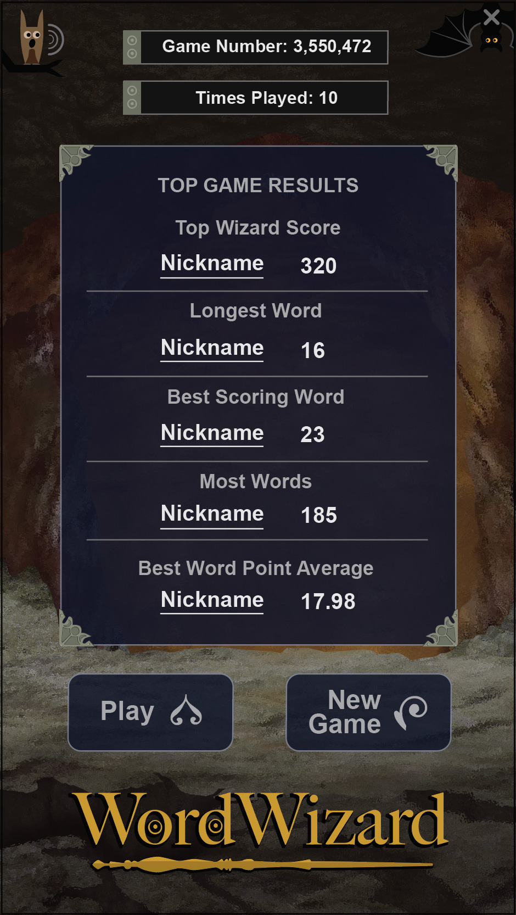

1. **WordWizard Design and Function: Game Puzzle Grid**

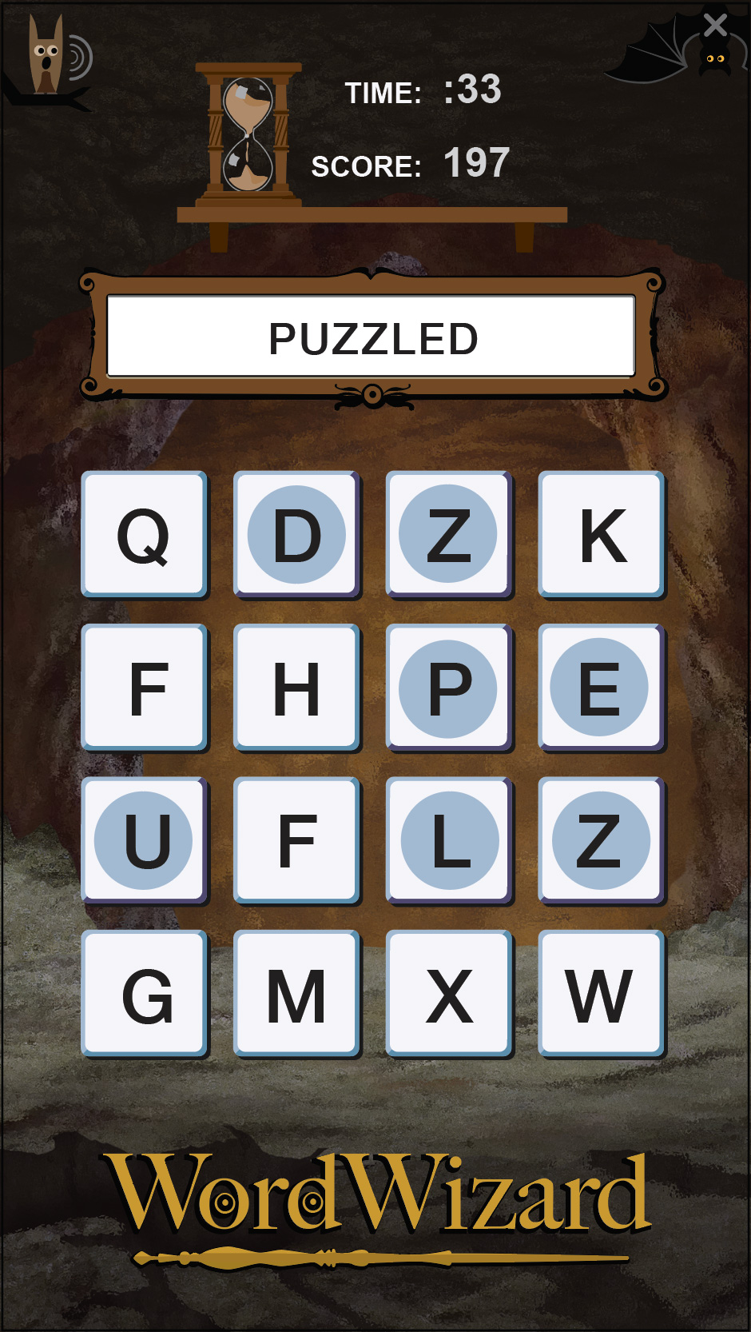

1. **WordWizard Design and Function: Game Player Result**

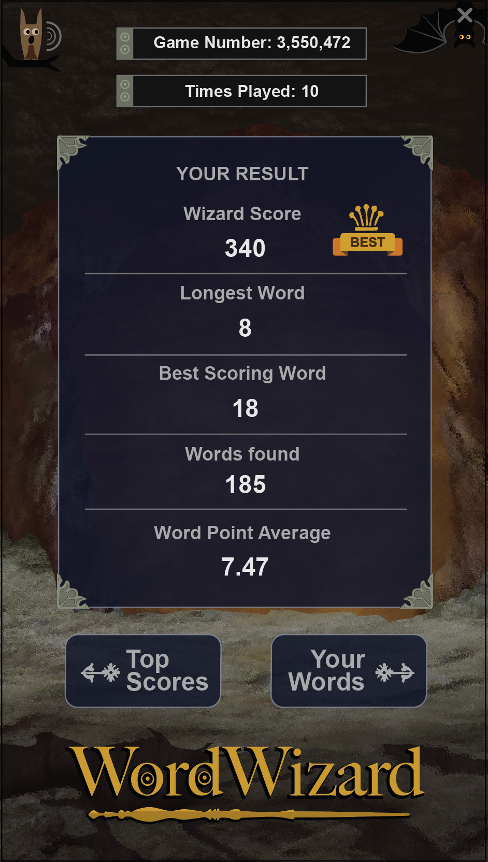

1. **WordWizard Design and Function: Words Found Results List**

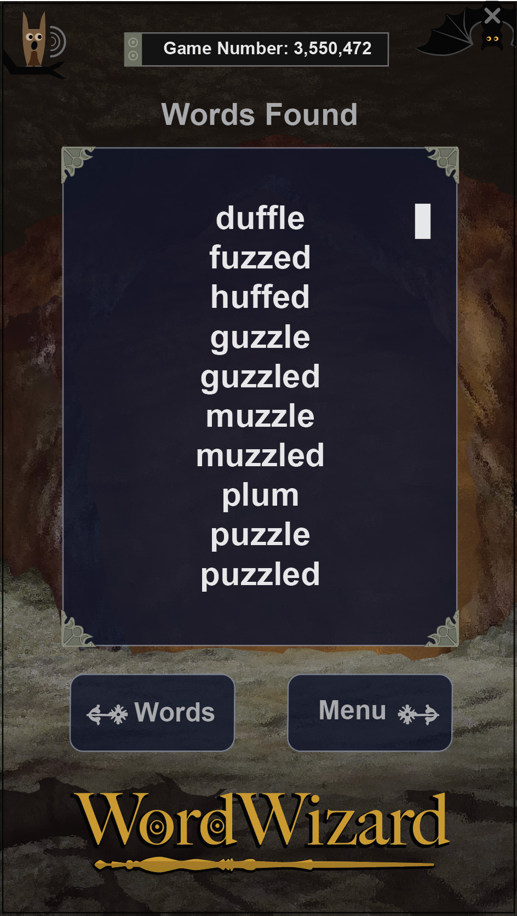

1. **WordWizard Design and Function: Main Menu Account Pop-Up**

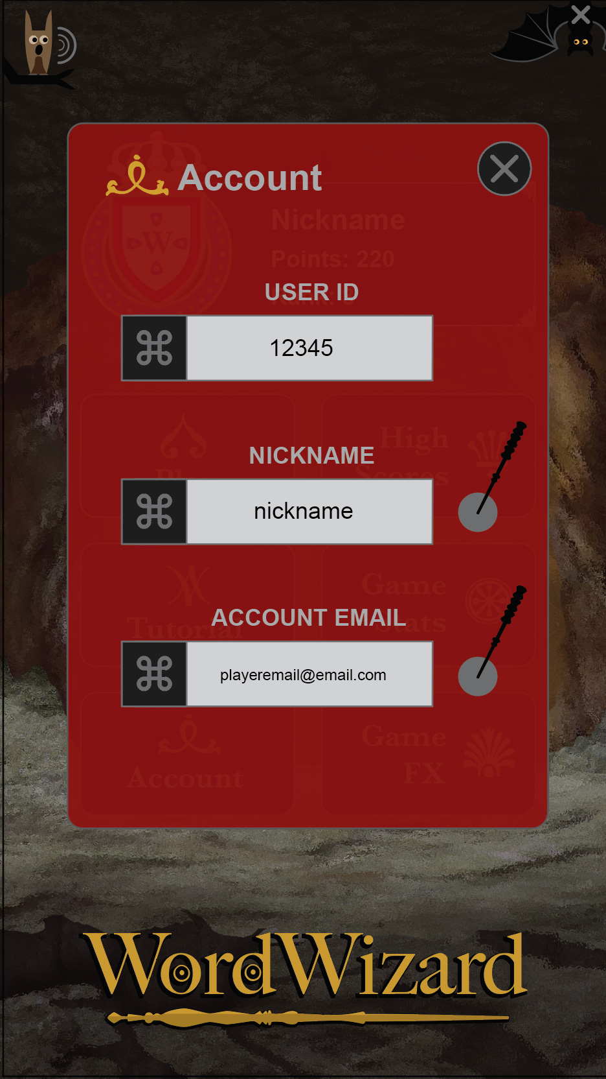

1. **WordWizard Design and Function: Main Menu Tutorial Pop-Up**

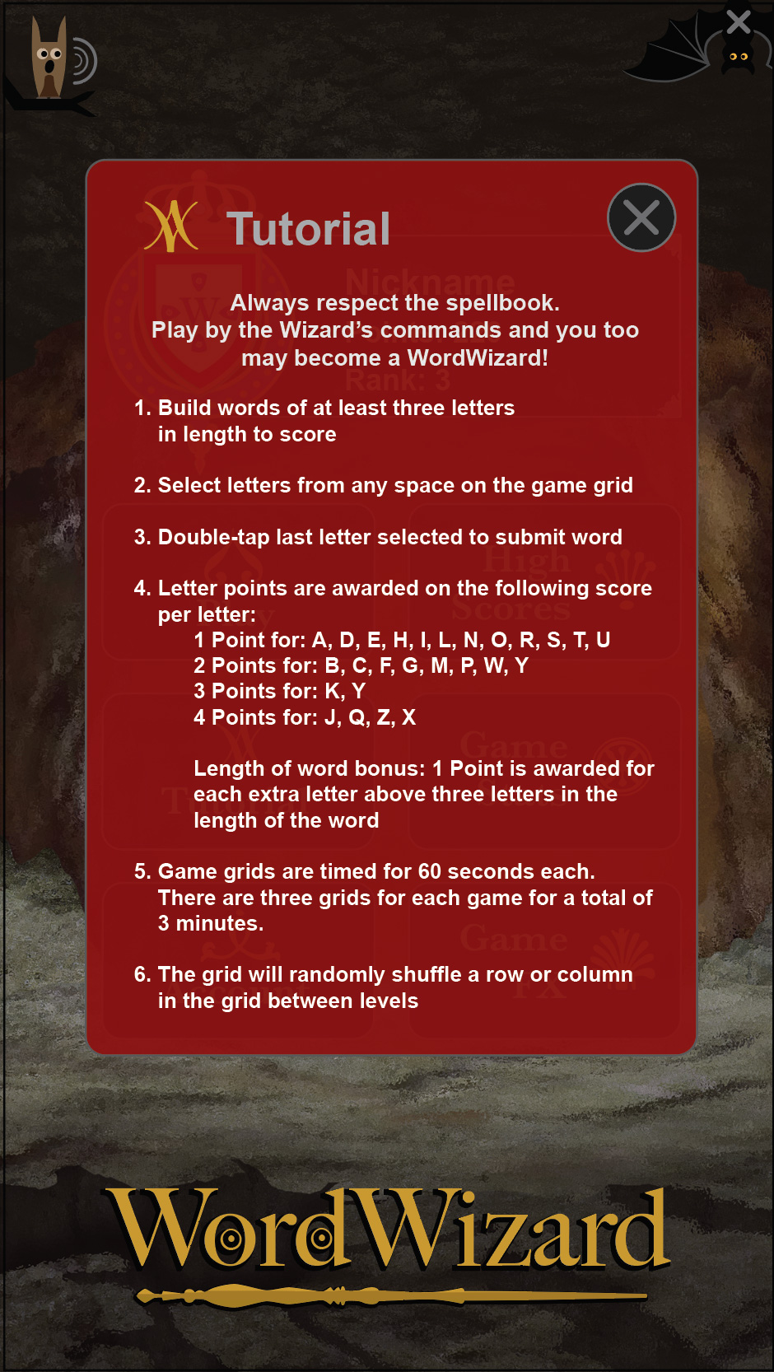

1. **WordWizard Design and Function: Main Menu Game Fx**

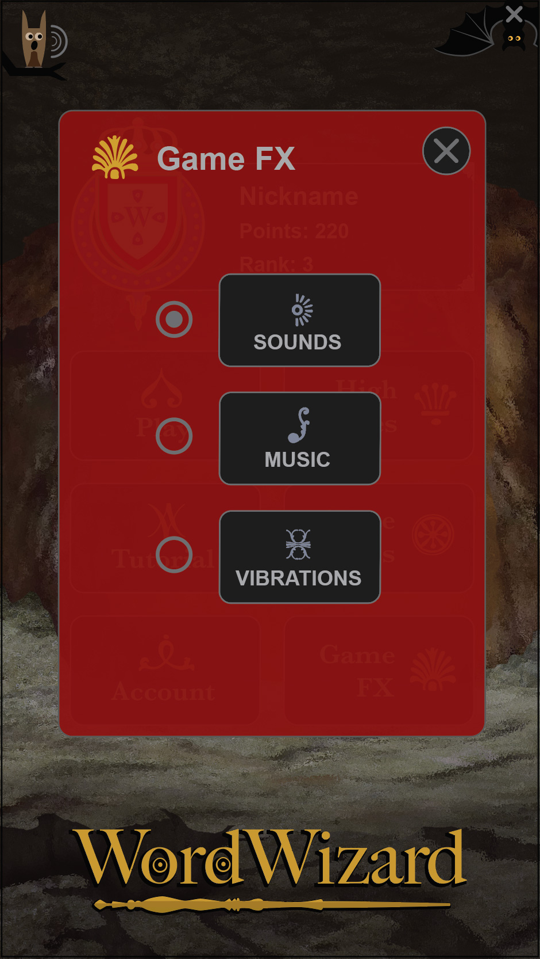

1. **WordWizard Process Function: Sign-Up Form**

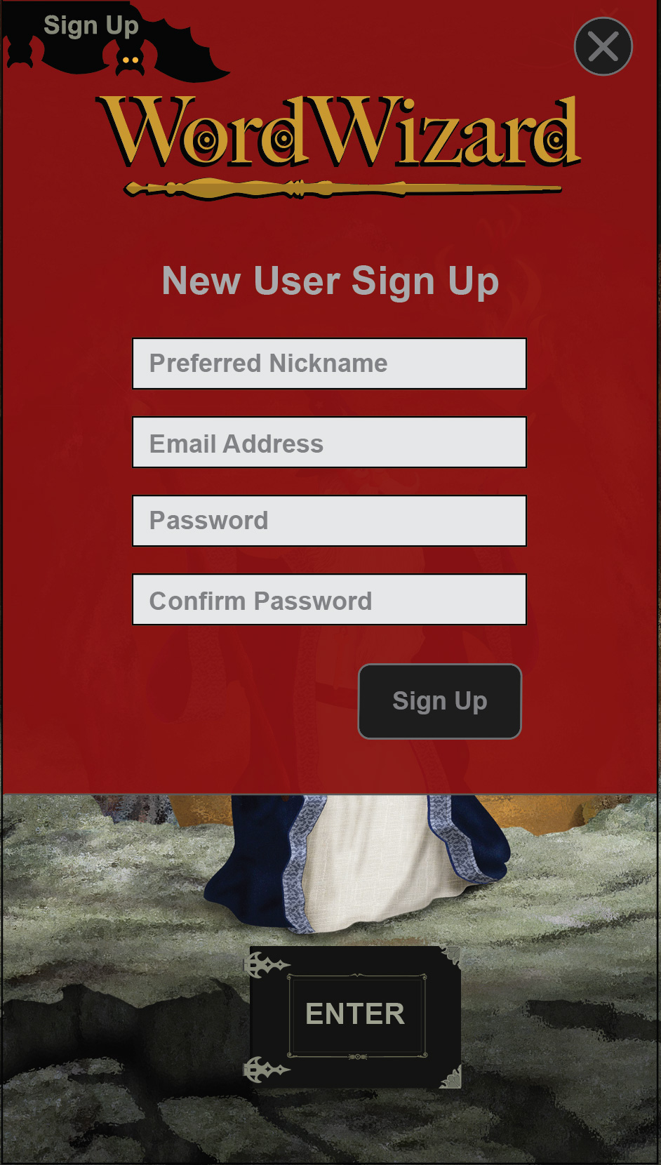

1. **WordWizard Process Function: Sign-In Form**

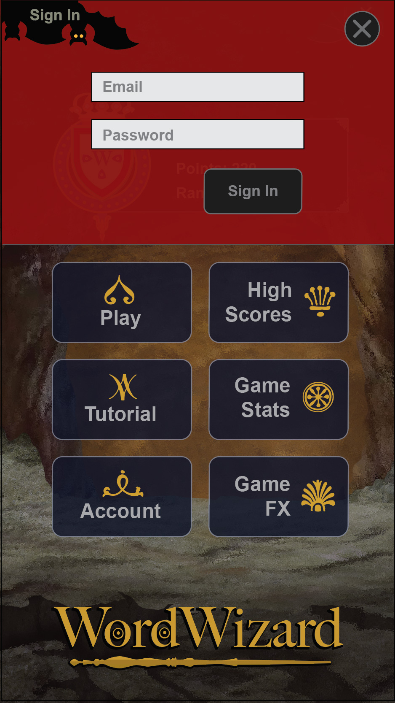

1. **WordWizard Process Function: Sign Out Affirmation**

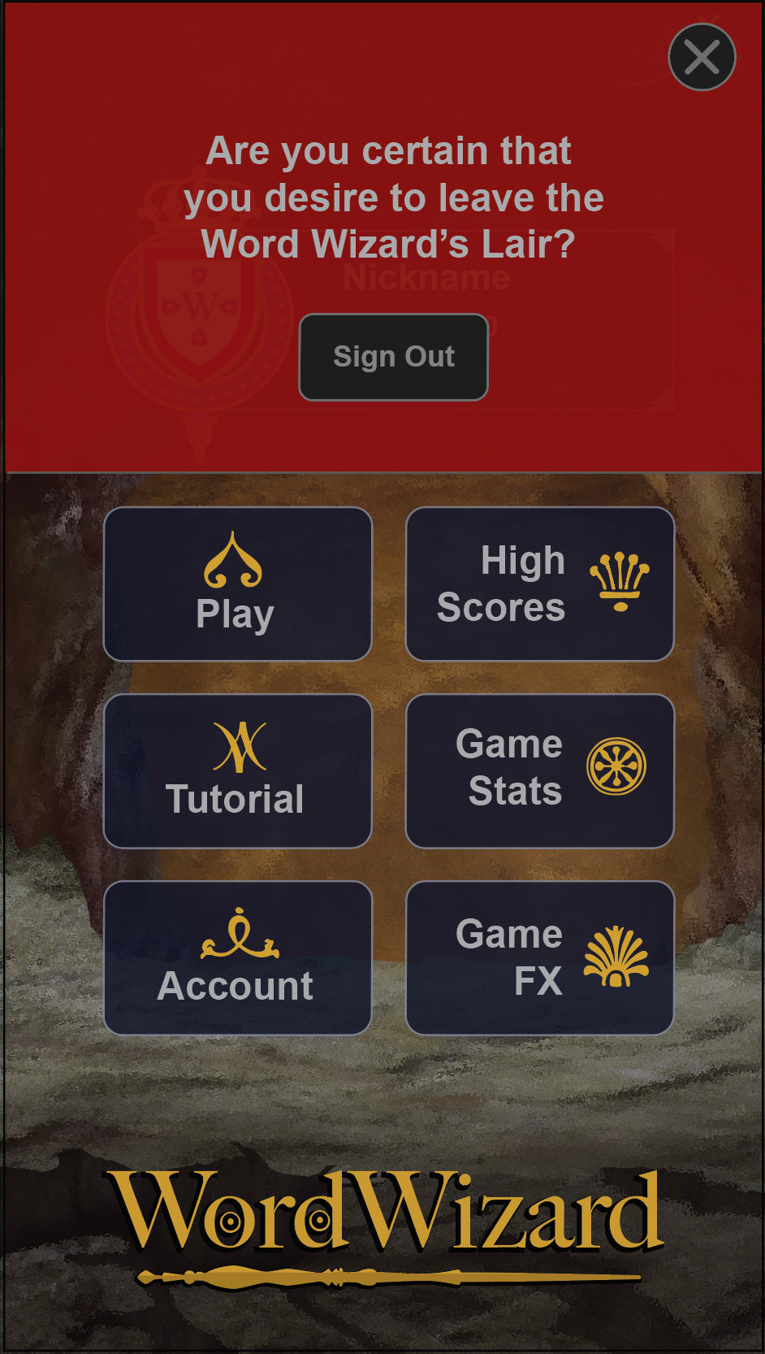

1. **WordWizard Data Function: Leaderboard**

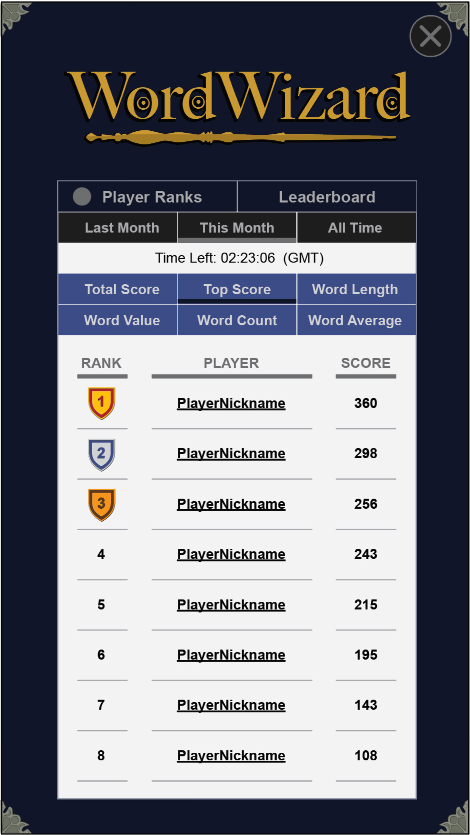

1. **WordWizard Data Function: Player Ranks**

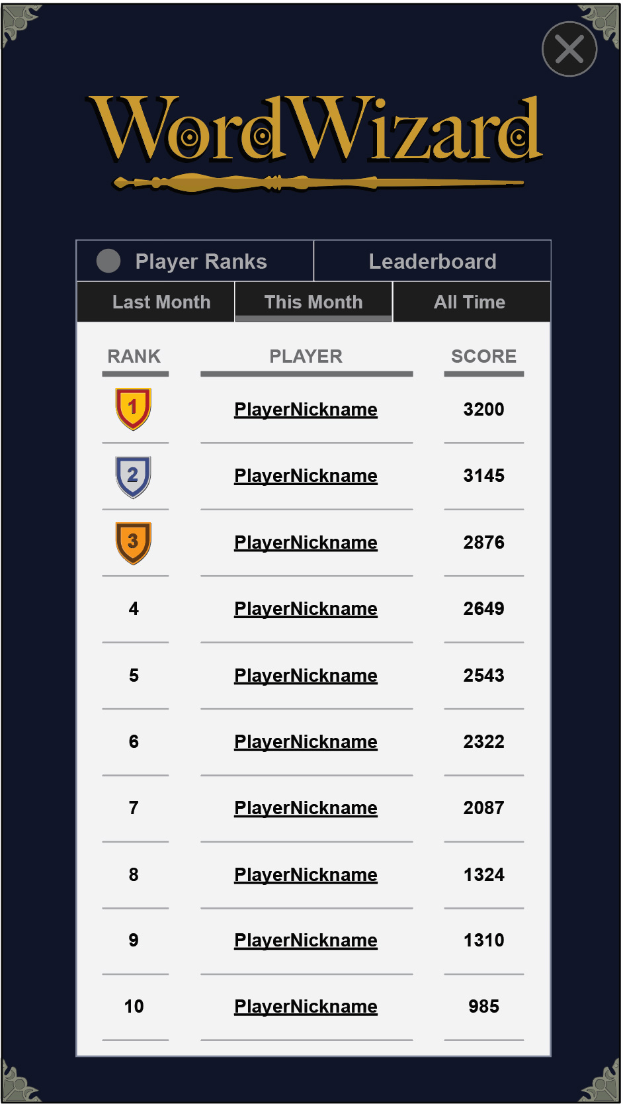

1. **WordWizard Data Function: User/Player Records**

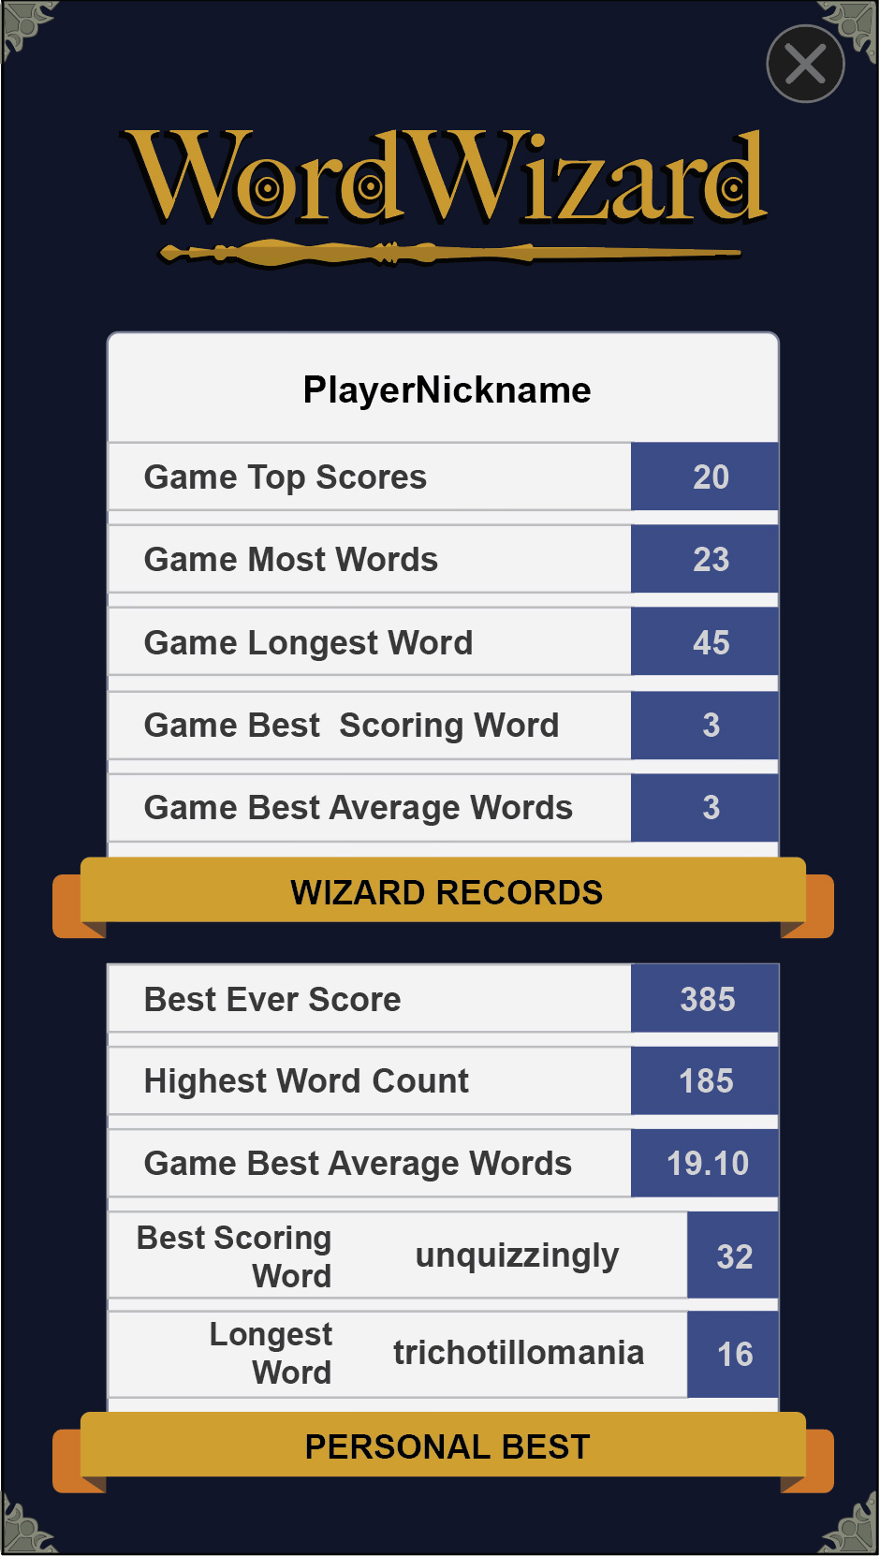

1. **Word Wizard Game Color Pallete**

